[Artif](https://doi.org/10.1016/j.aiia.2021.05.003)i[cial Intelligence in Agriculture 5 (2021) 102–117](https://doi.org/10.1016/j.aiia.2021.05.003)

|  |  |  |
| --- | --- | --- |
|  |  |  |
|  | |  | | --- | | Contents lists available at [ScienceDirect](http://www.sciencedirect.com/science/journal/) |  |  | | --- | | Artificial Intelligence in Agriculture |  |  | | --- | | journal homepage: [http://www.keaipublishing.com/en/journals/artificial-](http://www.keaipublishing.com/en/journals/artificial-intelligence-in-agriculture/) |   [intelligence-in-agriculture/](http://www.keaipublishing.com/en/journals/artificial-intelligence-in-agriculture/) |  |
| Non-destructive thermal imaging for object detection via advanced deep learning for robotic inspection and harvesting of chili peppers | |  |

Steven C. Hespeler, Hamidreza Nemati, Ehsan Dehghan-Niri⁎

Intelligent Structures and Nondestructive Evaluation (ISNDE), Civil Engineering Department, New Mexico State University, Las Cruces, NM, USA

|  |  |  |
| --- | --- | --- |
| a r t i c l e | i n f o | a b s t r a c t |
| Article history:  Received 15 March 2021  Received in revised form 11 May 2021 Accepted 11 May 2021  Available online 15 May 2021 | | Deep Learning has been utilized in computer vision for object detection for almost a decade. Real-time object de-tection for robotic inspection and harvesting has gained interest during this time as a possible technique for high-quality machine assistance during agriculture applications.We utilize RGB and thermal images of chili peppers in an environment of various amounts of debris, pepper overlapping, and ambient lighting, train this dataset, and compare object detection methods. Results are presented from the real-time and less than real-time object |
| Keywords:  Deep learning  You only look once (YOLO) v3 Object detection  Chili pepper fruit | | detection models. Two advanced deep learning algorithms, Mask-Regional Convolutional Neural Networks (Mask-RCNN) and You Only Look Once version 3 (YOLOv3)are compared in terms of object detection accuracy and computational costs. When utilizing the YOLOv3 architecture, an overall training mean average precision (mAP) value of 1.0 is achieved. Most testing images from this model score within a range from 97 to 100% con-fidence levels in natural environment. It is shown that the YOLOv3 algorithm has superior capabilities to the |

Mask-RCNN with over 10 times the computational speed on the chili dataset. However, some of the RGB test im-ages resulted in low classification scores when heavy debris is present in the image. A significant improvement in the real-time classification scores was observed when the thermal images were used, especially with heavy de-bris present. We found and report improved prediction scores with a thermal imagery dataset where YOLOv3 struggled on the RGB images. It was shown that mapping temperature differences between the pepper and plant/debris can provide significant features for object detection in real-time and can help improve accuracy of predictions with heavy debris, variant ambient lighting, and overlapping of peppers. In addition, successful ther-mal imaging for real-time robotic harvesting could allow the harvesting period to become more efficient and open up harvesting opportunity in low light situations.

© 2021 The Authors. Publishing services by Elsevier B.V. on behalf of KeAi Communications Co., Ltd. This is an open access article under the CC BY-NC-ND license (<http://creativecommons.org/licenses/by-nc-nd/4.0/>).

|  |  |
| --- | --- |
| 1. Introduction | the crop increased by 10 million tonnes per year, from 28 to 38 million |

tonnes (FAO, 2019). Fig. 2 visualizes the worldwide trend. While de-

Due to its lightly pungent, crisp, and smoky taste, the New Mexico chili pepper (Capsicum annuum) is widely popular in the Southwest re-gion of the USA. Sometimes referred to as chiles, the pepper in New Mexico is a cash crop with an annual harvesting of approximately 8000 to 10,000 acres and is used for consumption, processing into dried spice, or decorations (strung on ristras) (Bosland et al., 1991).

The agricultural production of chili peppers is the most consumed spicy crop throughout the world (Jiang et al., 2018). Throughout the world, the USA and other countries lack in total Capsicum annuum pro-duction compared to agricultural production achievements made by China in 2019. Fig. 1 displays the production quantities of the top 11

mand for the chili pepper has increased, harvest production has room for growth. Agriculture producer prices (prices for crops at the initial sale point) do not indicate quantity values of production. Although one of the smaller total producing countries with the least amount of land harvested, Netherlands achieved the highest selling point per hect-are (ha) of chili peppers among the entire group highlighted. Table 1 displays data from 2019 that showcases the production amount, land area harvested, producer price at the initial sale, and how much price each hectare produces for these countries (FAO, 2019). Using this data as a blueprint, countries with less land harvested could increase produc-tion to become more competitive and drive up their production yield

countries worldwide. per hectare. We aim to illuminate and provide insight into this issue.

Total world production and area harvested have steadily increased each year since 1994. From 2009 to 2019, worldwide production of

⁎ Corresponding author.

E-mail address: [niri@nmsu.edu](mailto:niri@nmsu.edu) (E. Dehghan-Niri).

<https://doi.org/10.1016/j.aiia.2021.05.003>

Nondestructive imaging for robotic harvesting has been an effective tool for assistance in the agriculture industry to harvest the fruit with debris present while not harming the plant (Gao et al., 2020). Due to the complexity of this task, an efficient object detection and inspection algorithm are necessary for a robotic platform to be used in pepper

2589-7217/© 2021 The Authors. Publishing services by Elsevier B.V. on behalf of KeAi Communications Co., Ltd. This is an open access article under the CC BY-NC-ND license ([http:// creativecommons.org/licenses/by-nc-nd/4.0/](http://creativecommons.org/licenses/by-nc-nd/4.0/)).

S.C. Hespeler, H. Nemati and E. Dehghan-Niri

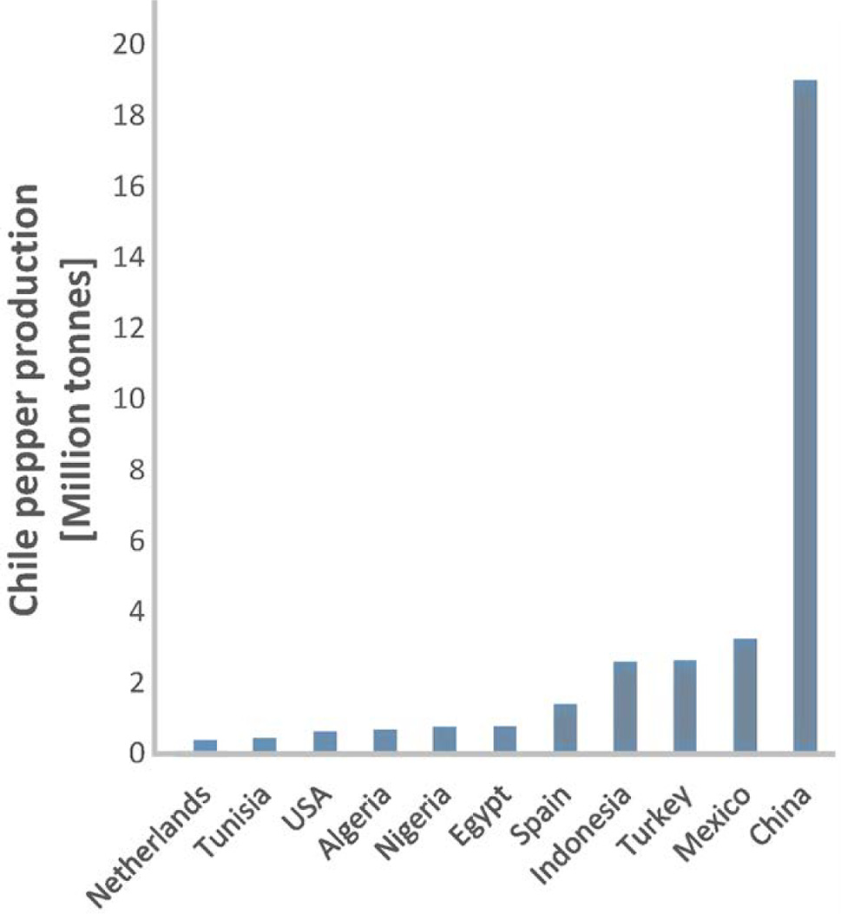

Fig. 1. Chili pepper production in 2019 (FAO, 2019).

harvesting. Nondestructive quality assessment of peppers has been studied successfully using near-infrared (NIR) hyper-spectral imaging to not harm the plant (Jiang et al., 2018).

Real-time robotic harvesting is a promising development in agricul-ture with some challenges (Kang et al., 2020). Challenges in this area re-sult from complex machine tasks that require powerful computation abilities, complex model architectures, and non-destructive measures,

Artificial Intelligence in Agriculture 5 (2021) 102–117

all while the machine is detecting the fruit. With advances in Convolu-tion Neural Network (CNN) techniques, object detection performance has rapidly increased in recent years and is a suitable solution for real-time robotic harvesting. Gu et al. showcase the recent growth of CNNs through a broad scope of literature (Gu et al., 2018). The survey high-lights several improvements that have propelled the expansion of CNN applications. A critical development is applying several new activa-tion functions that have increased in model performance. One ex-tremely effective activation function is the Rectified Linear Unit (ReLU). The transition to ReLU from sigmoid function solved the famous issue of vanishing gradient, which was impeding traditional Neural Net-works (NN) from learning on large datasets. ReLU can be mathemati-cally represented as:

ai,j,k ¼ max zi,j,k, 0� � ð1Þ

where zi, j, k is the input of the activation function located at (i,j). Other variants include Leaky ReLU (and many other variants), ELU, Maxout, and Probout. We refer the reader to the following reference for an in-depth analysis of CNN components (Gu et al., 2018).

Thermal imaging is used to convert invisible radiation patterns of a particular object to visible imaging for feature extraction (Vadivambal and Jayas, 2011). This type of imaging can be utilized as a non-destructive method during real-time robotic harvesting since it is non-contact, non-invasive, and rapid (Vadivambal and Jayas, 2011). We be-lieve mapping temperature differences between the pepper and plant/de-bris can provide significant features for object detection in real-time and can help improve accuracy predictions with heavy debris, variant ambient lighting, and overlapping of peppers. In addition, successful thermal imag-ing for real-time robotic harvesting could allow the harvesting period to become more efficient and open up harvesting opportunity in the evening hours or low light situations. Fig. 3 highlights how prominent thermal im-aging can be for extracting features than an RGB image.

Modern architectures (one-stage and two-stage) for object detec-tion is implemented on a custom dataset to detect chili peppers in real-time for robotic harvesting. In this investigation, we 1) compare

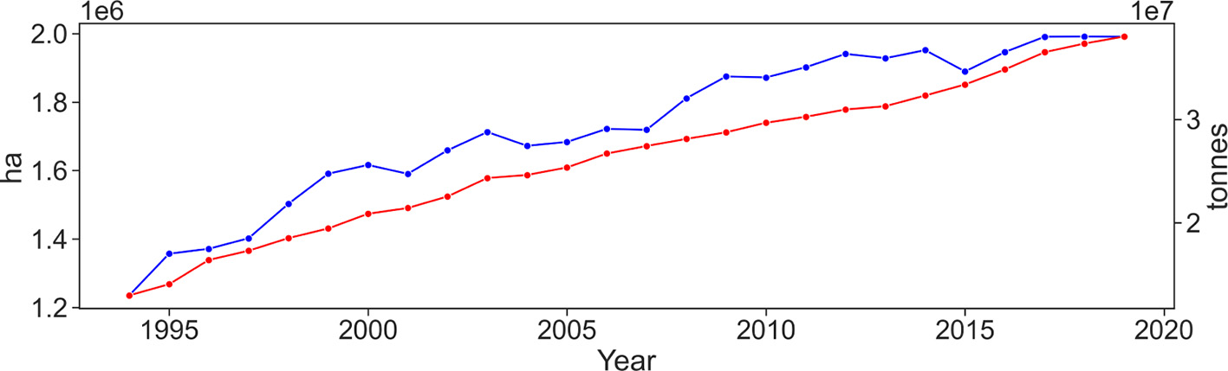

Fig. 2. Chili area harvested (blue) in ha and chili production (red) in tonnes (FAO, 2019).

Table 1   
Chili pepper data 2019 (FAO, 2019).

|  |  |  |  |  |
| --- | --- | --- | --- | --- |
| Country | Production (tonnes) | Area Harvested (ha) | Producer Price (USD/t) | Price per ha |
| Netherlands | 375,000 | 1500 | 1177 | $ 294,150.00 |
| Tunisia | 443,632 | 20,103 | 382 | $ 8425.54 |
| USA | 624,982 | 19,627 | 941 | $ 29,964.24 |
| Algeria | 675,168 | 21,767 | 643 | $ 19,953.86 |
| Nigeria | 753,116 | 99,715 | 1077 | $ 8130.47 |
| Egypt | 764,292 | 40,422 | 127 | $ 2395.62 |
| Spain | 1,402,380 | 21,430 | 927 | $ 60,662.91 |
| Indonesia | 2,588,633 | 300,377 | 1206 | $ 10,388.93 |
| Turkey | 2,625,669 | 92,089 | 432 | $ 12,308.76 |
| Mexico | 3,238,245 | 149,577 | 525 | $ 11,370.24 |
| China | 19,007,248 | 798,877 | 748 | $ 17,801.52 |

103

S.C. Hespeler, H. Nemati and E. Dehghan-Niri Artificial Intelligence in Agriculture 5 (2021) 102–117

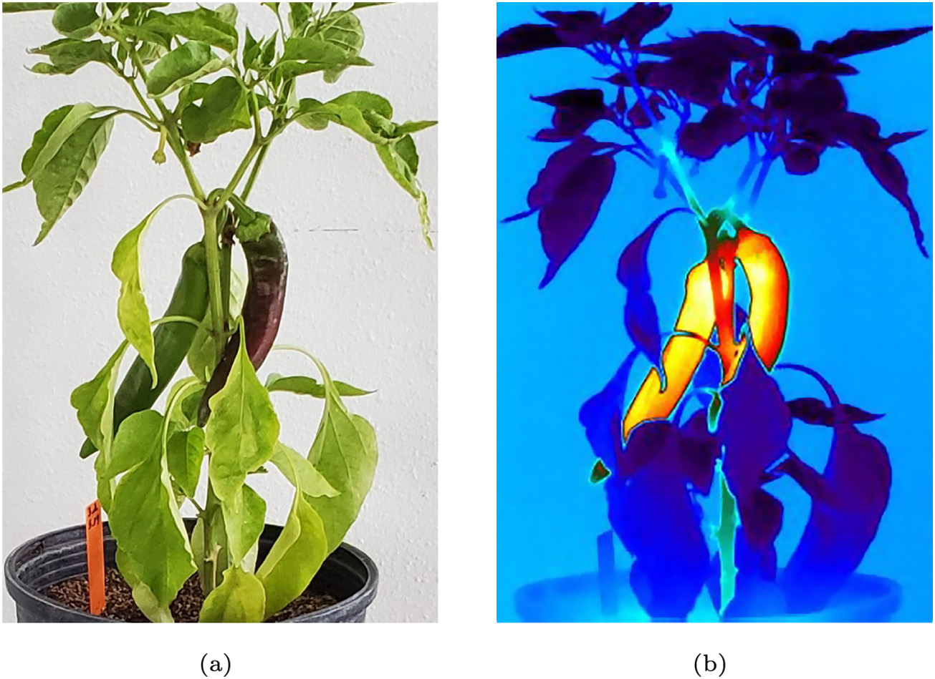

Fig. 3. (a) RGB image, (b) Thermal image.

imagery features on RGB and thermal datasets, 2) compare two modern object detection techniques on an RGB dataset for locating and identify-ing chili fruit, and 3) develop a thermal imaging technique to improve object detection on images with high debris, various ambient lighting, and overlapping peppers using YOLOv3.

window into cells (spatial regions) and combining localized histograms of gradients directions and edge orientations over every pixel. After the HOG descriptors are calculated, they are fed to a linear Support Vector Machine (SVM) for classification purposes.

The Deformable Part-based Model (DPM) was developed by Felzenszwalb et al. (2008) and builds off of the architecture from

|  |  |
| --- | --- |
| 2. Literature review  2.1. Object detection | (Dalal and Triggs, 2005). Using the underlying blocks, the model estab-lishes HOG descriptors via histogram gradient magnitudes within each 1D pixel. Filters are used to dictate weights in the detection window. Learning is accomplished on the PASCAL training data with a latent |

Object detection has a rich history of literature with vast improve-ments made recently that utilize computer vision to identify where

SVM. Using DPM, the authors won 2007, 2008, and 2009 Pascal Visual Object Classes (VOC) detection challenge (Everingham et al., 2007).

and what an object is in space. Literature generally accepts the notation

that two eras exist for the progression of object detection; traditional object detection before 2014 and the introduction of Deep Learning (DL) for object detection after 2014 (Zou et al., 2019). Before DL was uti-lized for object detection, many investigations were limited due to com-putation power and trainable image representation. We refer the reader to (Zou et al., 2019) for a comprehensive survey on object detection.

2.1.1. Traditional object detection   
 Viola and Jones (2001), introduced the Viola-Jones detector with the purpose of robust rapid and real-time detection. In this work, the au-thors focus on simple features rather than pixels to speed the detection process up.Three main contributionswere madein thestudy.1) Integral Image which is a method for using intermediate image representation for rapid rectangle computation, 2) an algorithm based on AdaBoost for feature extraction by combing some features to form an effective classifier, and 3) a cascade method for classification to discard or pass on viable information for further analysis and ultimately, increased de-tection performance. Viola and Jones (2004) demonstrated the robust-ness of this method by applying the techniques to facial recognition. Viola et al. (2005), utilized the cascade method for moving person de-tection along with AdaBoost for increasingly complex rejection regions based on a rule system.

Another cornerstone in object detection was introducing the Histo-grams of Oriented Gradient (HOG) detection system presented in Dalal and Triggs (2005). In this investigation, Dalal et al. created a method that utilizes edge direction and gradient intensity to determine the appearance of an image. This task is accomplished by separating the

104

S.C. Hespeler, H. Nemati and E. Dehghan-Niri Artificial Intelligence in Agriculture 5 (2021) 102–117

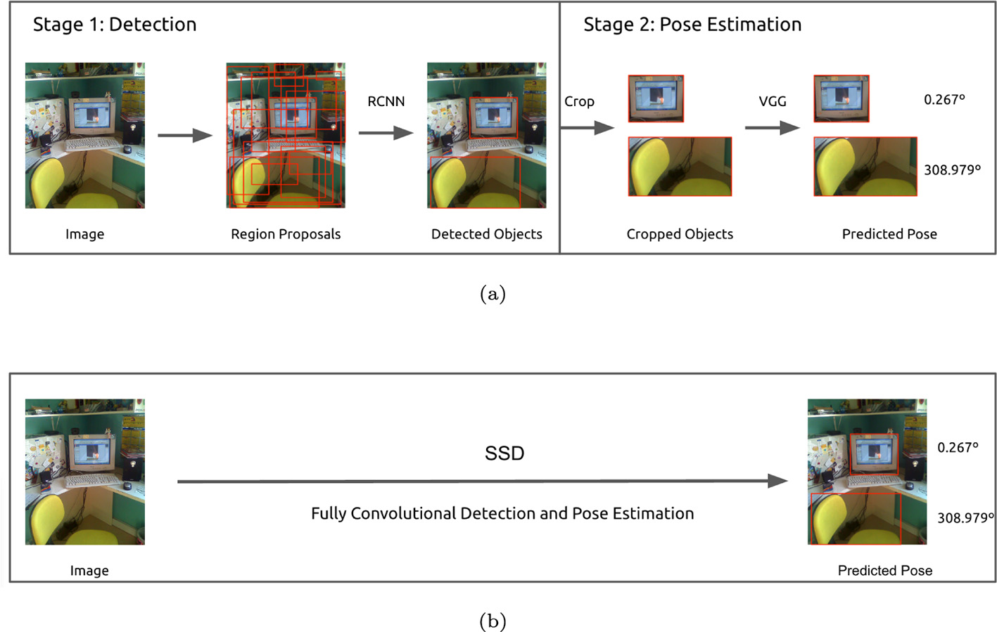

Fig. 4. Two/One-stage detectors (Poirson et al., 2016): (a) Two-stage, (b) One-stage.

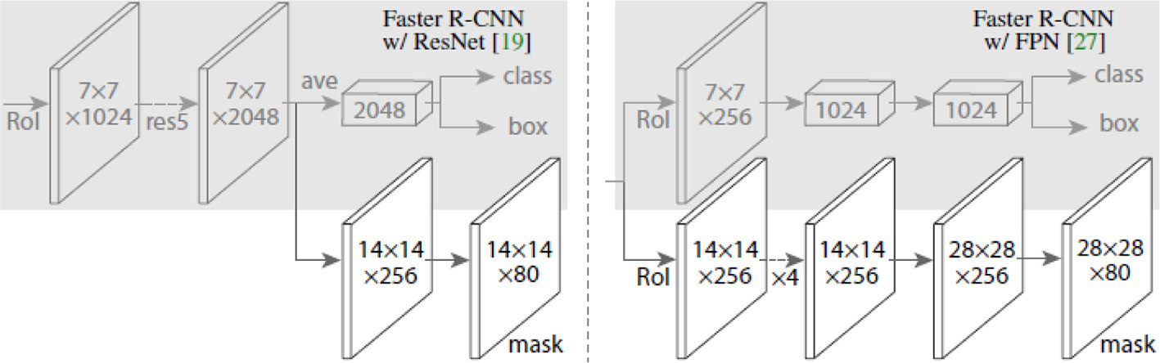

Fig. 5. Head architecture for Mask R-CNN (He et al., 2017).

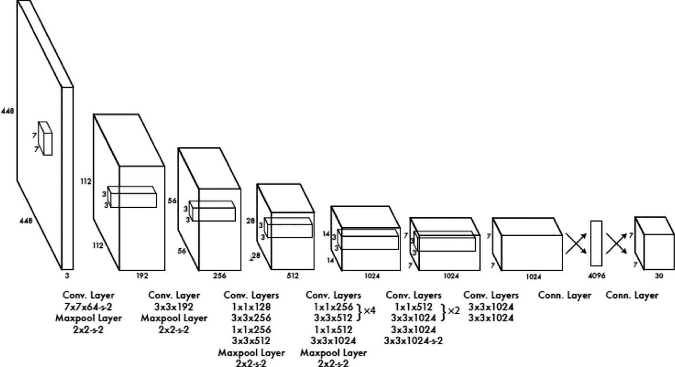

Fig. 6. YOLO architecture (Redmon et al., 2016.

Girshick (2015), improved on the R-CNN by simplifying the learning process. The authors realized that the R-CNN is slow due to the network performing a “forward pass for each object proposal”. Spatial Pyramid

105

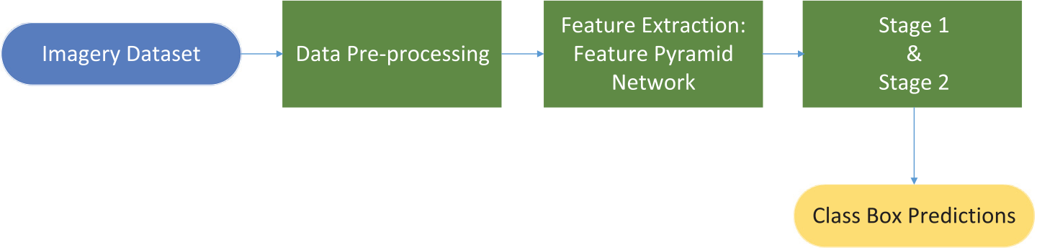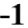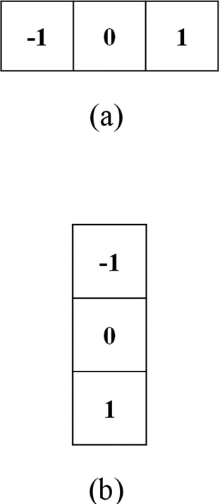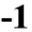

S.C. Hespeler, H. Nemati and E. Dehghan-Niri

Table 2   
YOLO performance (Redmon et al., 2016).

|  |  |  |  |
| --- | --- | --- | --- |
| Real-Time Detectors | Train | mAP | FPS |
| 100 Hz DPM (Sadeghi and Forsyth, 2014) | 2007 | 16.0 | 100 |
| 30 Hz DPM (Sadeghi and Forsyth, 2014) | 2007 | 26.1 | 30 |
| Fast YOLO | 2007 + 2012 | 52.7 | 155 |
| YOLO | 2007 + 2012 | 63.4 | 45 |

Less Than Real-Time

|  |  |  |  |
| --- | --- | --- | --- |
| Fastest DPM (Yan et al., 2014) | 2007 | 30.4 | 15 |
| R-CNN Minus R (Lenc and Vedaldi, 2015) | 2007 | 53.5 | 6 |
| Fast R-CNN (Girshick, 2015) | 2007 + 2012 | 70.0 | 0.5 |
| Faster R-CNN VGG-16 (Ren et al., 2015) | 2007 + 2012 | 73.2 | 7 |
| Faster R-CNN ZF (Ren et al., 2015) | 2007 + 2012 | 62.1 | 18 |
| YOLO VGG-16 | 2007 + 2012 | 66.4 | 21 |

Fig. 7. HOG filter: (a) Horizontal kernel, (b) Vertical kernel.

improvements on the fast R-CNN design in the same year to move the algorithm closer to real-time detection speeds. This version became the first end-to-end and close to real-time object detector (Zou et al., 2019). In the first stage, a Region Proposal Network (RPN) considers a candidate bounding box. In the second stage, feature extraction is com-pleted using Region of Interest (RoI) pooling (RoIPool) from each candi-date which executes classification and bounding box regression (Ren et al., 2015).

Mask R-CNN is an extension of the fast R-CNN architecture and gen-erates a high-quality segmentation mask for each instance while effi-ciently detecting objects in an image (He et al., 2017). Using various Feature Pyramid Network (FPN) frameworks, R-50-FPN, R-101-FPN, X-101-FPN, and X-152-FPN, AP performance was measured at 40.8 and 70.4 for enhanced detection and enhanced keypoint results, respec-tively. Fig. 5 details the head architecture of the algorithm and high-lights the exact improvements made to the Faster R-CNN.

Here, we see the algorithm applied with the ResNet (left) and FPN backbones.



Artificial Intelligence in Agriculture 5 (2021) 102–117

2.1.4. CNN one-stage based detectors   
 You Only Look Once (YOLO) is a real-time detecting system created by Redmon et al. (2016) with several incremental improvements through the years (Redmon and Farhadi, 2017; Redmon and Farhadi, 2018). Most recent improvements have been made by Bochkovskiy et al. (2020). The original system design gets its name from only looking at an image once, therefore treating every image (input) as a regression problem. Compared to R-CNN architectures that are complex pipelines, this improvement in simplicity might be the most important aspect of the YOLO system. The system consists of 3 main steps. First, inputs are resized to 448 × 448. Next, a single CNN is run. Finally, the Non-max Suppression (NMS) technique attempts to correct multiple detections on the same image.

The YOLO architecture consists of 24 convolutional layers followed by 2 fully connected layers. Fig. 6 shows the details of each layer in the basic YOLO architecture. The network outputs a 7 × 7 × 30 tensor of predictions.

In 2018 Redmon et al. established an incremental improvement to the network design to include 53 convolutional layers. This version demonstrated exceptional accuracy due to the more robust design and is 3.8 times faster than RetinaNet. At the time of publication (2016), the YOLO system achieved more than twice the mPA compared to the next best real-time system, 63.4% mAP to 26.1%, respectively. It also ob-serves the entire image, unlike region proposal-based architectures. Table 2 summarizes the performance of YOLO compared to other real-time and less than real-time systems (Redmon et al., 2016).

Another critical aspect of YOLO performance is that when compared to Fast R-CNN, YOLO had a smaller percentage of background errors but more significant percentage of localization errors. DL, especially CNNs, have been thrust upon the robotic harvesting research area for assis-tance during agriculture applications. The research area has seen a surge in investigations in 2019 and 2020 (Naranjo-Torres et al., 2020). In Hameed et al. (2018), investigators present a critical comparison of multiple modern computer vision techniques investigated by re-searchers to classify fruit and vegetables. In the study, Support Vector Machine (SVM), K-Nearest Neighbour (KNN), Decision Trees, Artificial Neural Networks (ANN), and CNN's are reviewed for a variety of fruit and vegetable classification. However, the Mask R-CNN and YOLOv3 methods are not evaluated in the investigation.

Li et al. (2019), reviewed non-destructive optical techniques for berries, mainly strawberries and blueberries. The researchers identified and reviewed 13 methods, one of which was computer vision. The re-view did not detail specific computer vision techniques; however, sev-eral studies are mentioned that detail computer vision as a viable method for berry classification. The researchers state that one main issue with computer vision is “inconsistent ambient illumination and complex background.” For these reasons, we have selected the YOLOv3 for real-time object detection.

2.2. Object detection in agriculture

In the past decade, different object detection methods have been successfully adopted in several agricultural applications. Hameed et al.

Fig. 8. Mask R-CNN block diagram.   
106

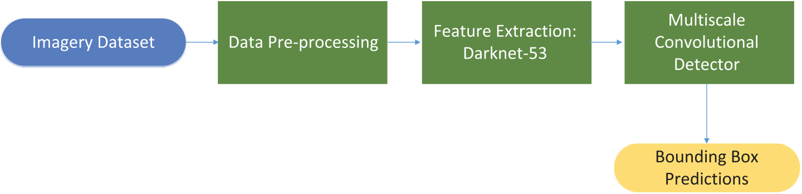

S.C. Hespeler, H. Nemati and E. Dehghan-Niri Artificial Intelligence in Agriculture 5 (2021) 102–117



Fig. 9. YOLOv3 block diagram.

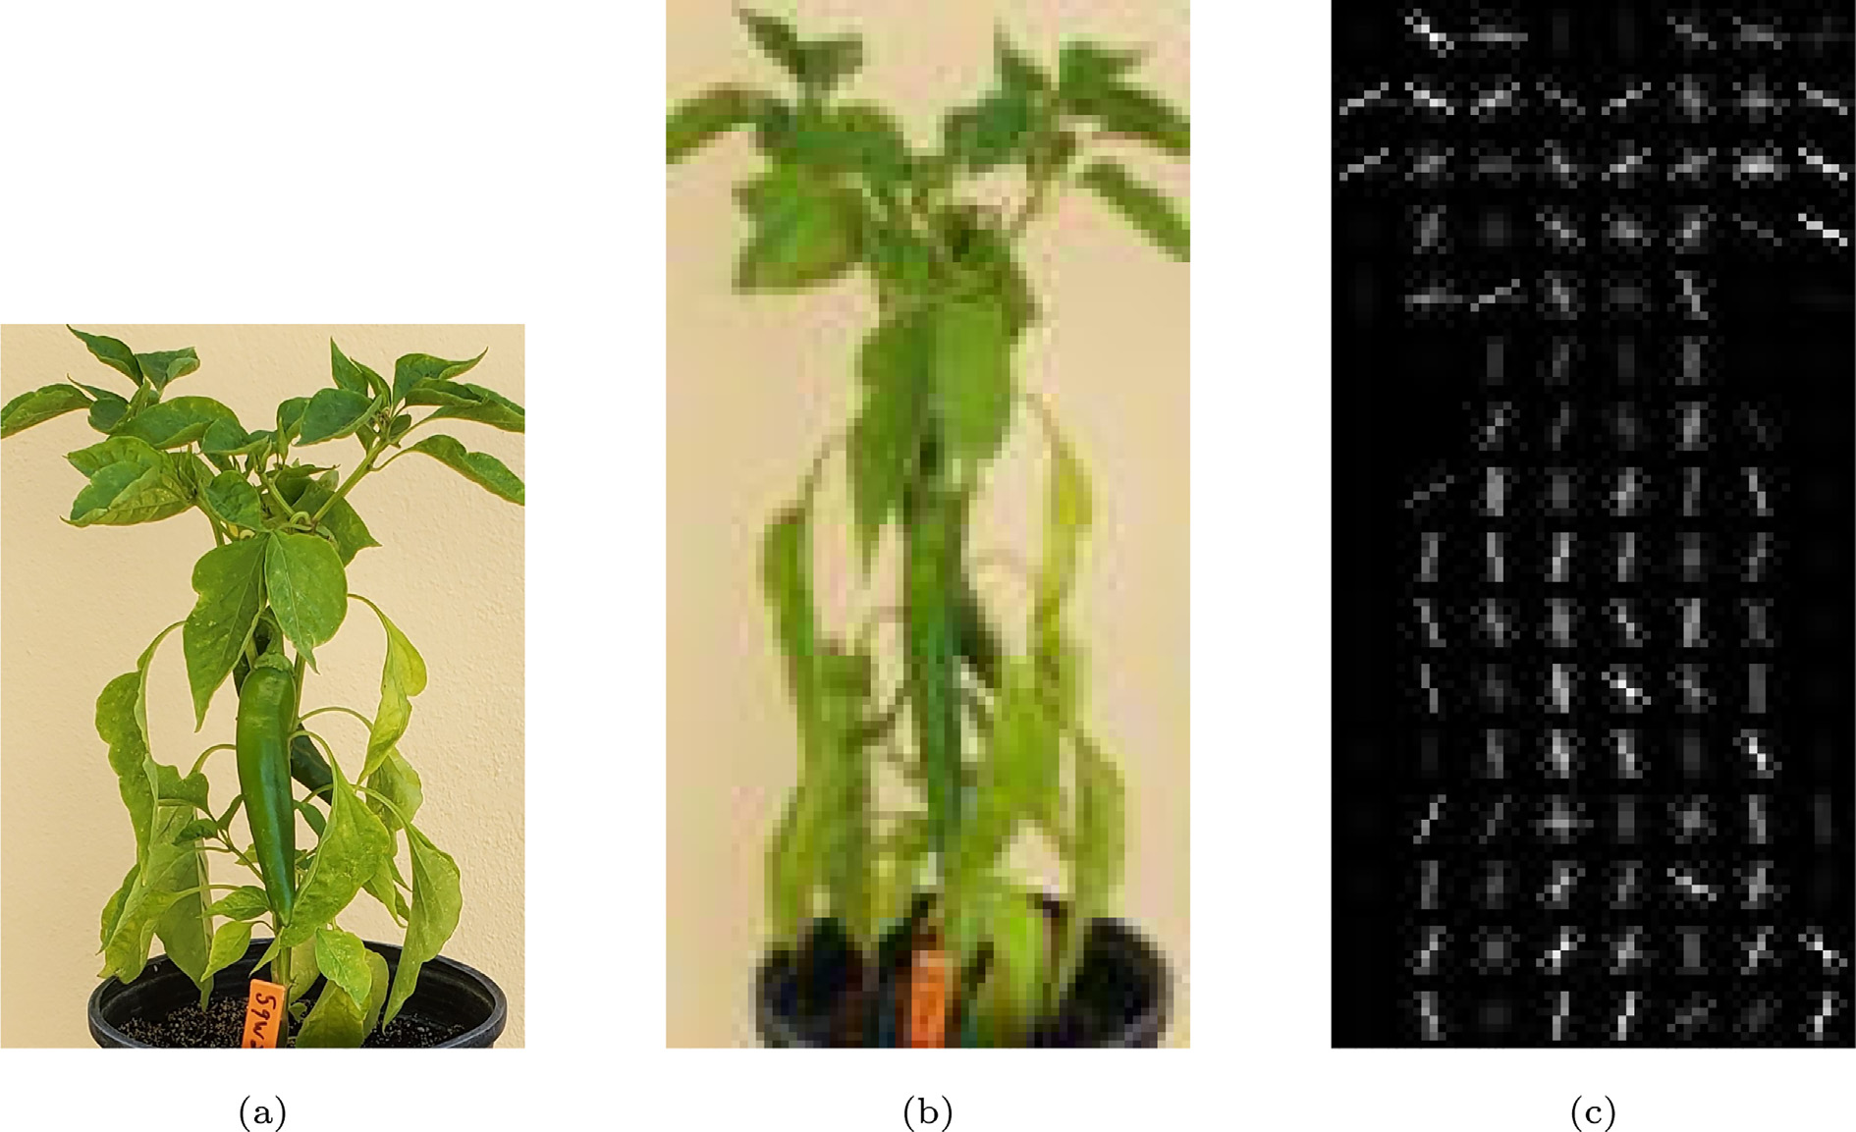

Fig. 10. RGB HOG images: (a) Original RGB image, (b) Resized RGB image, (c) HOG RGB.

highlighted the complexities of classifying fruit and vegetables. Specifi-cally, they looked at the issue of identifying fruits and vegetables at su-permarket self-checkout systems (Hameed et al., 2020a). The authors applied pre-trained weights via transfer learning and an ensemble method to weights of GoogleNet and MobileNet for an optimized aver-age weight. Results demonstrated that these pre-trained weights posi-tively affected the model, with the ensemble method reaching accuracy measurements higher than training and testing datasets. Hameed et al. (2020b), proposed a novel technique to the supermarket fruit and vegetable classification issue by incorporating a progressive fruit and vegetable classifier with AdaBoost-based optimization of a CNN. 15 classes, 1000 images in each class, of fruits and vegetables were considered for training. The method began by coarsely classifying fruits and vegetables into three categories via the Jenks Natural Breaks classification method. From there, the classes were implemented to three CNNs (GoogleNet, MobileNet-v2, and a custom-designed net-work) for more detailed classification. The optimized AdaBoost CNN outperformed the custom CNN. Accuracy of the CNN with AdaBoost optimization ranged from 97.60% (navel orange) to 99.87% (ladyfinger banana) with less than 3% error for all classes. The custom 15 layer CNN achieved test accuracy ranges of 80.13% (10 epochs) to 93.97% (22 epochs).

107

S.C. Hespeler, H. Nemati and E. Dehghan-Niri Artificial Intelligence in Agriculture 5 (2021) 102–117

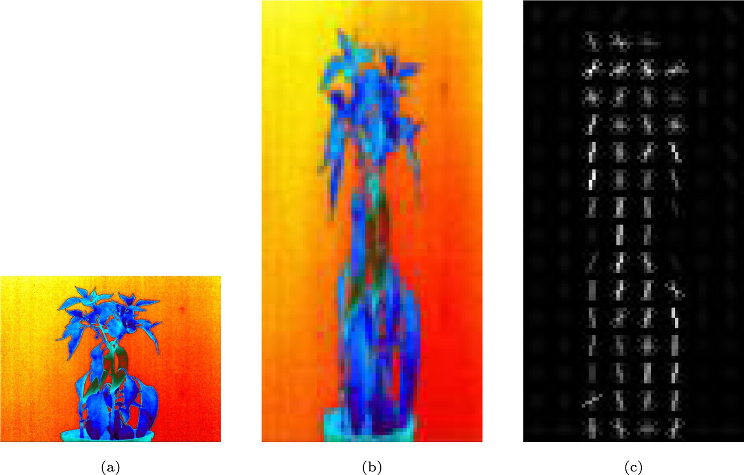

Fig. 12. Thermal HOG images: (a) Original thermal image, (b) Resized thermal image, (c) HOG thermal.

Several recent studies have attempted to improve or test modern object detection methods to use real-time robotic harvesting. Wan and Goudos (2020), utilized an improved Faster R-CNN architecture to detect fruits (apples, mango's, oranges) for robot picking applications.

Fast R-CNN, and Faster R-CNN in terms of detection speed and mAP%. When the authors fed their dataset to YOLOv3 they achieved a 40 ms/ image detection speed and mAP % of 90.03. So, they were able to soften the gap of performance between the Faster R-CNN and YOLOv3

In the investigation, the authors reported on 1) how their model up- architectures.

dates hyperparameters during the training phase of their model, 2) how the model augments data on high-quality images, and 3) optimi-zation of the convolutional and pooling layers of their Faster R-CNN model. Specifically, feature extraction was completed with a CNN model VGG-16 using 13 convolutional layers, 13 ReLu layers, and four pooling layers. Two loss functions were added to optimize the convolutional and pooling layers, allowing the parameters to adjust au-tomatically during training. They found that automatically tuning pa-rameters resulted in 58 ms/image detection speed with mAP % of 90.72. These results were compared to YOLO, YOLOv2, YOLOv3, Fast R-CNN, and Faster R-CNN, of which their model outperformed YOLO,

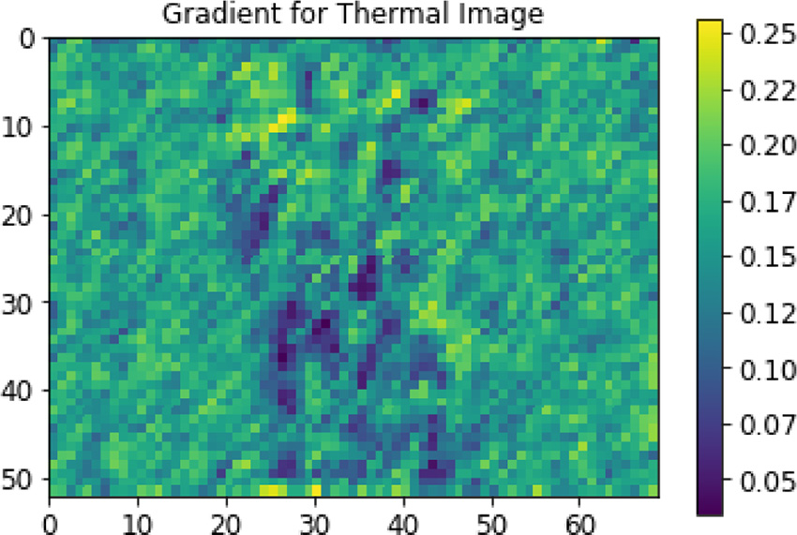

Fig. 13. Gradients of thermal images.

108

S.C. Hespeler, H. Nemati and E. Dehghan-Niri

that utilized a portable hyperspectral imagery machine to estimate the ripeness of strawberries. Two wavelengths were selected based on a forward SFS algorithm and feed to an SVM. Finally, a CNN was imple-mented to predict deep spatial features, and the model achieved an ac-

Artificial Intelligence in Agriculture 5 (2021) 102–117   
The datasets in this study were constructed as thermal and RGB color images to detect the chili peppers. To this end, we monitored two different chili plants during their growth period. The first chili pep-per was a raw, green one, and the second was mature. The RGB images

curacy of 98.6%. were acquired from conventional digital cameras with no preprocessing

and saved on a standard JPEG file format. At the same time, thermal im-

|  |  |
| --- | --- |
| 3. Methodology | ages of chili peppers were collected using a Forward Looking Infrared camera (FLIR A615). The camera is highly accurate with easy setup |

3.1. Image representation   
 Vision-based fruit detection is a critical component for in-field auto-mation and robotic fruit harvesting. However, this technology could also be leveraged in other applications such as disease detection, matu-rity detection, crop health status monitoring (Patel et al., 2011).

and automated inspection software. It is sensitive enough to detect tem-perature changes as small as 50 mK. The spectral range of the thermal camera is 7.5 − 14 μm with an absolute thermal accuracy of ±2°C or±2%, and thermal sensitivity of <0.05° at 30 °C. The camera produces thermal images with up to 640 by 480 resolution at 60 frames per second.

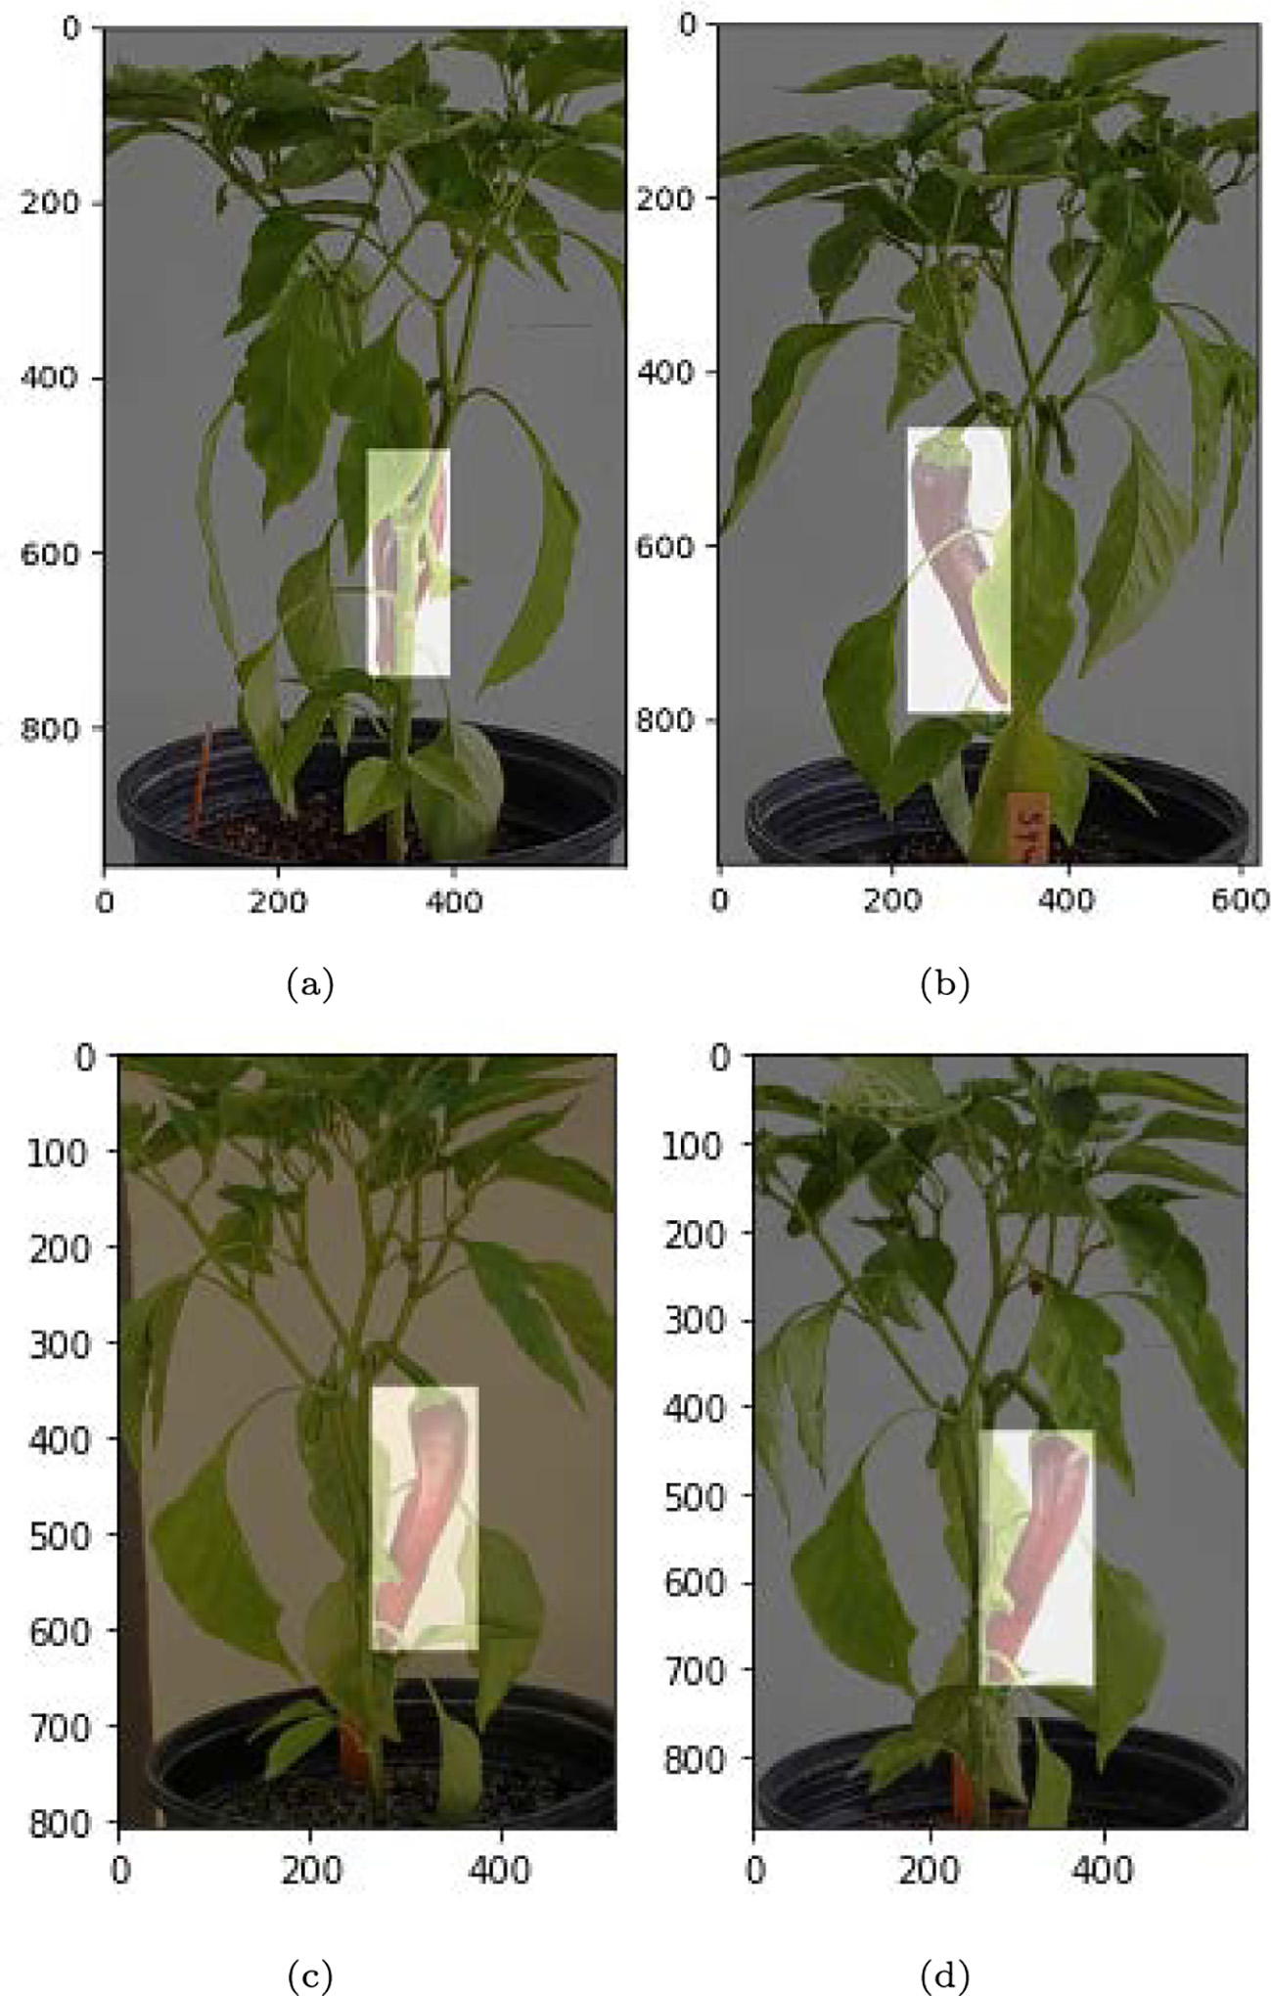

Fig. 14. Images with masks: (a)Mask 1, (b)Mask 2, (c) Mask 3, (d) Mask 4.   
109

S.C. Hespeler, H. Nemati and E. Dehghan-Niri

Both cameras were mounted over the chili plants at a fixed dis-tance of 130 cm with a light background. The thermal camera was fully controlled with the FLIR Tools; In fact, pre or post-processing could be done on an individual image, using ResearchIR software. Using an IR lens with a focal length of 13.1 mm, 112 thermal images (Besides 112 RGBs) were captured every other day over three months. On each day, four different images were taken from different directions for a single plant. Some of the images were captured in an outdoor setting and in natural light to validate the proposed

Artificial Intelligence in Agriculture 5 (2021) 102–117

Where, TP is true positive, FP is false positive, and FN is false neg-ative. True positives are when the model correctly classifies the object detection. False positive occurs when there is incorrect object detec-tion. False negative occurs when ground truth bounding boxes are present in the image and the model fails to detect the object in the image. True negative (TN) is not considered for this application since it would be correctly not labeling parts of the image that do not have truth bounding boxes.

technique. 3.3. Implementation of object detection models

3.2. Performance metrics   
 Unlike other ML applications, object detection classification is not bi-nary, as in true or false. Therefore, the performance metrics used have

Annotation files were generated for each image with the LabelImg software (tzutalin, 2017). Mask R-CNN was implemented in a Conda en-vironment and operated with Python 3.6, Tensorflow 1.14, and Keras 2.24 packages. Next, we cloned the Github repository Mask R-CNN

been tailored for these exact operations. Intersection of Union (IoU) from (Abdulla, 2017).

gives the user the ability to measure how well bounding boxes are being predicted with respect to truth boxes greater than a user-identified threshold. In other words, IoU is a measurement of the object localization accuracy between the truth boxes and predicted boxes (Zou et al., 2019). Eq. 2 defines IoU:

The YOLOv3 model was computed on GPU with CUDA version 10.1, V10.1.243. The architecture was cloned from the Github repository cre-ated by Bochkovskiy (2020).

3.3.1. HOG implementation in Python

|  |  |  |
| --- | --- | --- |
| IoU ¼Area of Overlap | ð2Þ | A prerequisite for using the HOG method is that all images must be |
| an array of shape (128,64). Therefore, all images were dropped then |
| transformed using skimage resize tool in python (van der Walt et al., |

Here, we are measuring the magnitude of overlap between the ground truth box and predicted box. In literature, an accepted threshold tends to be 0.5. That is:

|  |  |  |
| --- | --- | --- |
| � | IoU ≥ 0:5 | TP |
| IoU < 0:5 | FP |

2014). The HOG descriptors work by applying a filter to the image. The vertical and horizontal gradients are calculated with the kernels shown in Fig. 7.

Magnitude and direction are calculated by Eqs. 5 and 6, respectively:

|  |  |  |
| --- | --- | --- |
| g ¼ | q ffiffiffiffiffiffiffiffiffiffiffiffiffiffiffiffi | ð5Þ |

|  |  |  |  |  |  |
| --- | --- | --- | --- | --- | --- |
| So, if the measurement is at or higher than 0.5 the object will be suc-cessfully identified. Precision and recall are used as a metric to evaluate performance. We define precision and recall in Eqs. 3 and 4 below. | | | | θ ¼ arctan gy gx | ð6Þ |
| Precision ¼ | | TP | ð3Þ | 3.3.2. Implementation of one and two-stage detection models   We select two top-performing algorithms from two-stage and one-stage detectors for implementation on our dataset. After the data was prepared, we split our test/train sets to 20/80% to train on as many im-ages as possible due to the dataset being small. As stated in Section 2.1.2, | |
| TP þ FP |
| Recall ¼ | TP | | ð4Þ |
| TP þ FN | |

the Mask R-CNN utilizes FPN and a ResNet101 backbone. For the Mask   
R-CNN model, we first loaded bounding boxes and then masks for   
each image. We utilized a python tool to ensure that the masks were ap-

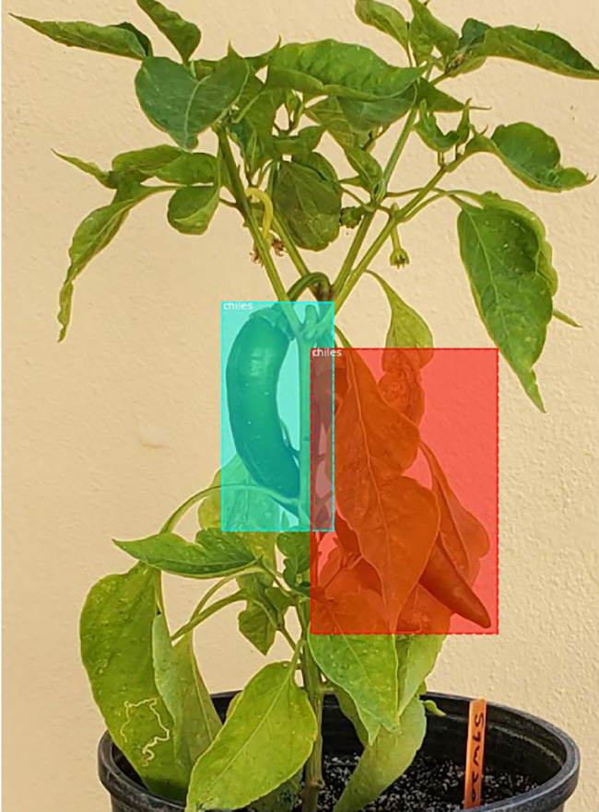

Fig. 15. Mask R-CNN prediction box.

110

|  |  |  |
| --- | --- | --- |
| S.C. Hespeler, H. Nemati and E. Dehghan-Niri | bx ¼ σ tx ð Þ þ cx  by ¼ σ ty  bw ¼ pwetw� �þ cy  bh ¼ pheth | Artificial Intelligence in Agriculture 5 (2021) 102–117 |
| images were similar in size but not the same. Feature maps are |
| downsampled via a convolutional layer with a stride of 2. Fig. 9 walks |
| through the process of how our data is implemented into YOLOv3. |
| Once the dataset is prepared, the YOLOv3 model extracts features |
| with Darknet-53. During feature extraction, three feature matrices are |
| created of sizes 1) 52 × 52, 2) 26 × 26, and 3) 13 × 13. These feature ma- |

trices are fed to the multiscale convolutional detector where the fea-tures are concatenated through multi-step convolutions.

We batch and input images with size (m,416,416,3) and output bounding boxes labeled (pc,bx,by,bh,bw,c). The bounding box predic-tions are calculated by:

where, bx, by, bh, andbw are bounding box center coordinates at x, y and width and height of the prediction box. tx, y, w, h are network outputs. Object scores are calculated as the probability (between 0 and 1) that

an object is inside a bounding box from a sigmoid activation function.

We report all findings in Section 4.3.

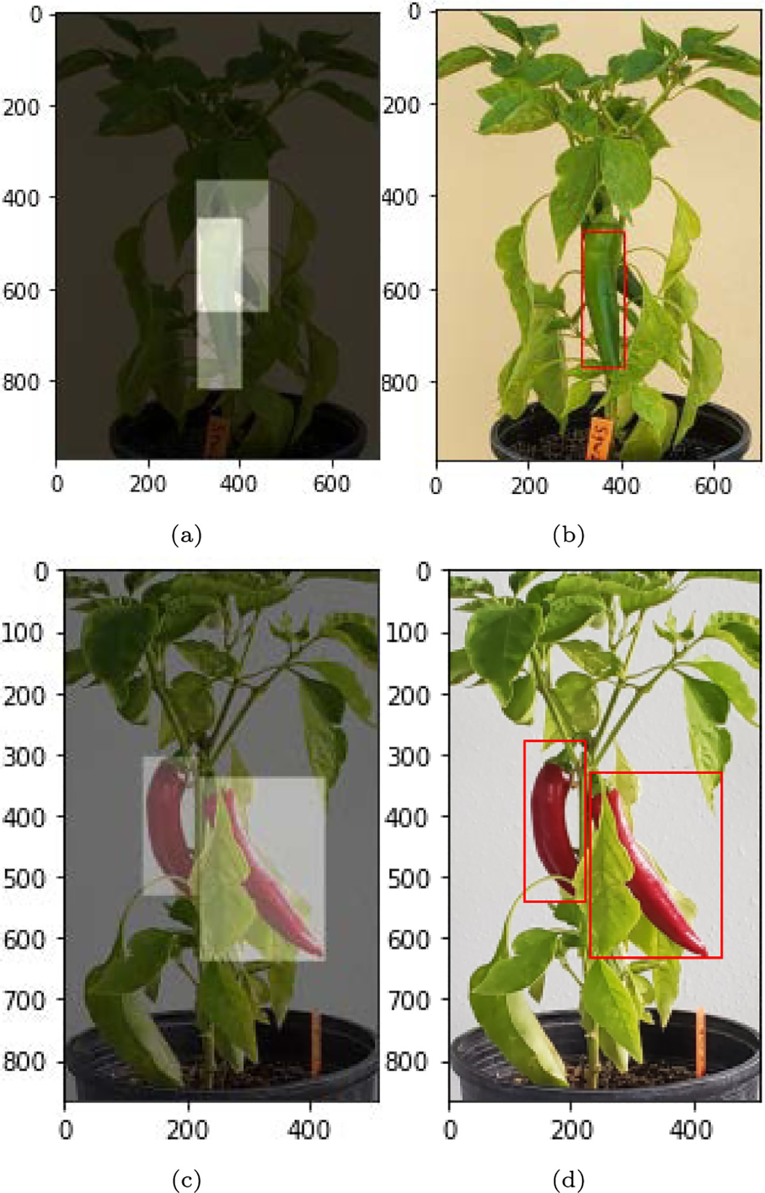

Fig. 16. Actual vs predicted plots for Mask-RCNN: (a) Actual plot image 1, (b) Predicted plot image 1, (c) Actual plot image 2, (d) Predicted plot image 2.

111

S.C. Hespeler, H. Nemati and E. Dehghan-Niri

4. Results and discussion

This section provides the results of all experimentation completed during training. Here we show the viability of certain techniques ap-plied to a chili pepper dataset in an environment with complex back-grounds and good ambient illumination. Section 4.1 details the HOG algorithm results, Section 4.2 provides results for the Mask R-CNN archi-tecture, and Section 4.3 shows results from real-time detection using the YOLOv3 architecture. The RGB dataset was considered for experi-mentation on the HOG, Mask R-CNN, and YOLOv3 models.

Computer vision is a highly researched area with many new and cutting-edge technology. As a result, terminology can sometimes get confusing. AP was first introduced by VOC2007 (Everingham et al., 2007) and the calculation is applied to every image within the labeled set and measures the average AP of the entire set. We follow the COCO definition for mAP terminology as:   
 AP is averaged over all categories. Traditionally, this is called “mean average precision” (mAP). We make no distinction between AP and mAP (and likewise AR and mAR) and assume the difference is clear from context (Common Objects in Context (COCO) (2021)).

Therefore, we define mAP as:

Artificial Intelligence in Agriculture 5 (2021) 102–117

directions in Fig. 10c. When plotting the normalized histograms in Fig. 10c, there is visual evidence (intensity) of the HOG detector recog-nizing the shape of the entire plant and even demonstrating a connec-tion to the chili pepper centralized in the original image.

Gradient intensity of the histograms is visually represented as they increase in color in the image from the color map in Fig. 11. Gradient values range from 0 to 0.35 and visualize distinct features of the chili plant and pepper. Edges of the pepper and leaves have lower gradient values when compared to the background of the image. These values are close to zero (purple), while the center of the pepper display gradi-ents between 0.30 and 0.25. The background displays gradient values ranging between 0.20 and 0.35. Here we show the regional location of where the chili pepper is within the normalized histogram plot. A plot of the gradients demonstrates evidence that the HOG method can out-line the chili pepper in Fig. 11.

When we move to a thermal image, HOG detectors appear to have less visual evidence of detecting a pepper. Fig. 12 depicts features of a thermal image. The feature extraction process is represented with the original image in Fig. 12a, the resized thermal image in Fig. 12b, and the gradient directions in Fig. 12c. Gradient directions from the 12c plot does not show the distinct region of the pepper, but it does demon-strate the shape of the entire plant.

|  |  |  |  |
| --- | --- | --- | --- |
| N mAP ¼1 N∑i¼1 | APi | ð7Þ | Gradients range from 0 to 0.25 in Fig. 13 and display the gradient |
| values of the thermal image from Fig. 12a. The plot of gradient values |
| does not demonstrate a clear feature pattern and the variation between |

where, APi is the average precision at image i and N is the total number of images. The mAP metric is usually used as a final metric to compare performance throughout all object categories (Zou et al., 2019), which we use to evaluate experiments with both the Mask R-CNN and YOLOv3 models.

4.1. HOG results

The HOG method allows for visual feature extraction and compari-son, which can be seen in Figs. 10, 11, 12, and 13. The purpose of using the HOG method in this experiment was to visualize gradient di-rection and intensity between RGB and thermal images of chili peppers. In Fig. 10, we show the process of transforming the original image in Fig. 10a, resizing the image in Fig. 10b, and finally plotting gradient

gradient values is much less in Fig. 13 compared to Fig. 11 (<0.1). The HOG algorithm was an effective technique to visualize how features may be represented in computer vision. Figs. 11 and 13 demonstrate through gradient intensities that RGB images have stronger features when compared to thermal images.

4.2. Mask RCNN

Due to its ability to produce highly accurate mAP responses, we uti-lized the Mask R-CNN architecture to analyze and compare results from the Mask R-CNN to the YOLOv3 model. Before training, we ensure that image and mask arrays have identical width and height. Fig. 14 shows four images with masks overlaid to confirm masks were loading

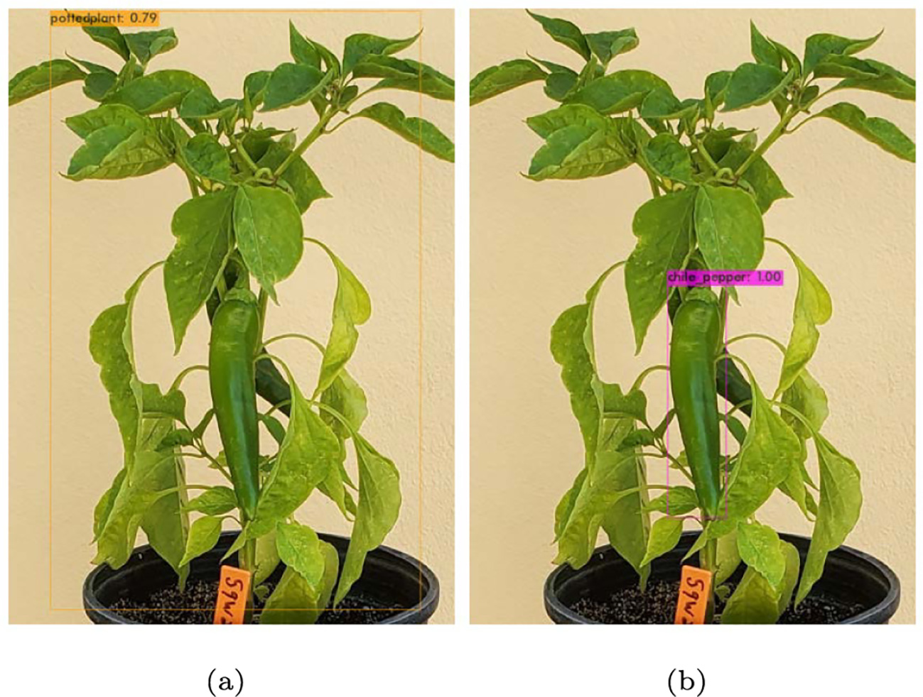

Fig. 17. Predictions from pre-trained YOLO Weights: (a) Out-of-Box chili pepper prediction, (b) TRAINED chili pepper prediction. 112

S.C. Hespeler, H. Nemati and E. Dehghan-Niri

properly. For example, Fig. 14d output an image shape of (881,562,3) and a mask shape of (881,562,1). We utilize the following tool:

visualize.display_instance

This python tool is used to call the plot in Fig. 15. Here, we demon-strate the ability of this particular architecture to detect chili peppers in an environment with debris. We visualize that the Mask R-CNN

Artificial Intelligence in Agriculture 5 (2021) 102–117

algorithm has identified and located all chili peppers in the image (with different colors), assigned a prediction bounding box, and labeled it with the appropriate label (chili pepper). As covered in Section 3.2, precision and recall are determined by evaluating truth bounding boxes and predicted bounding boxes. While training on the RGB dataset, the Mask R-CNN performed with a train mAP of 0.872 and test mAP of 0.896 with an overall computational time of 40.79 s per test image.

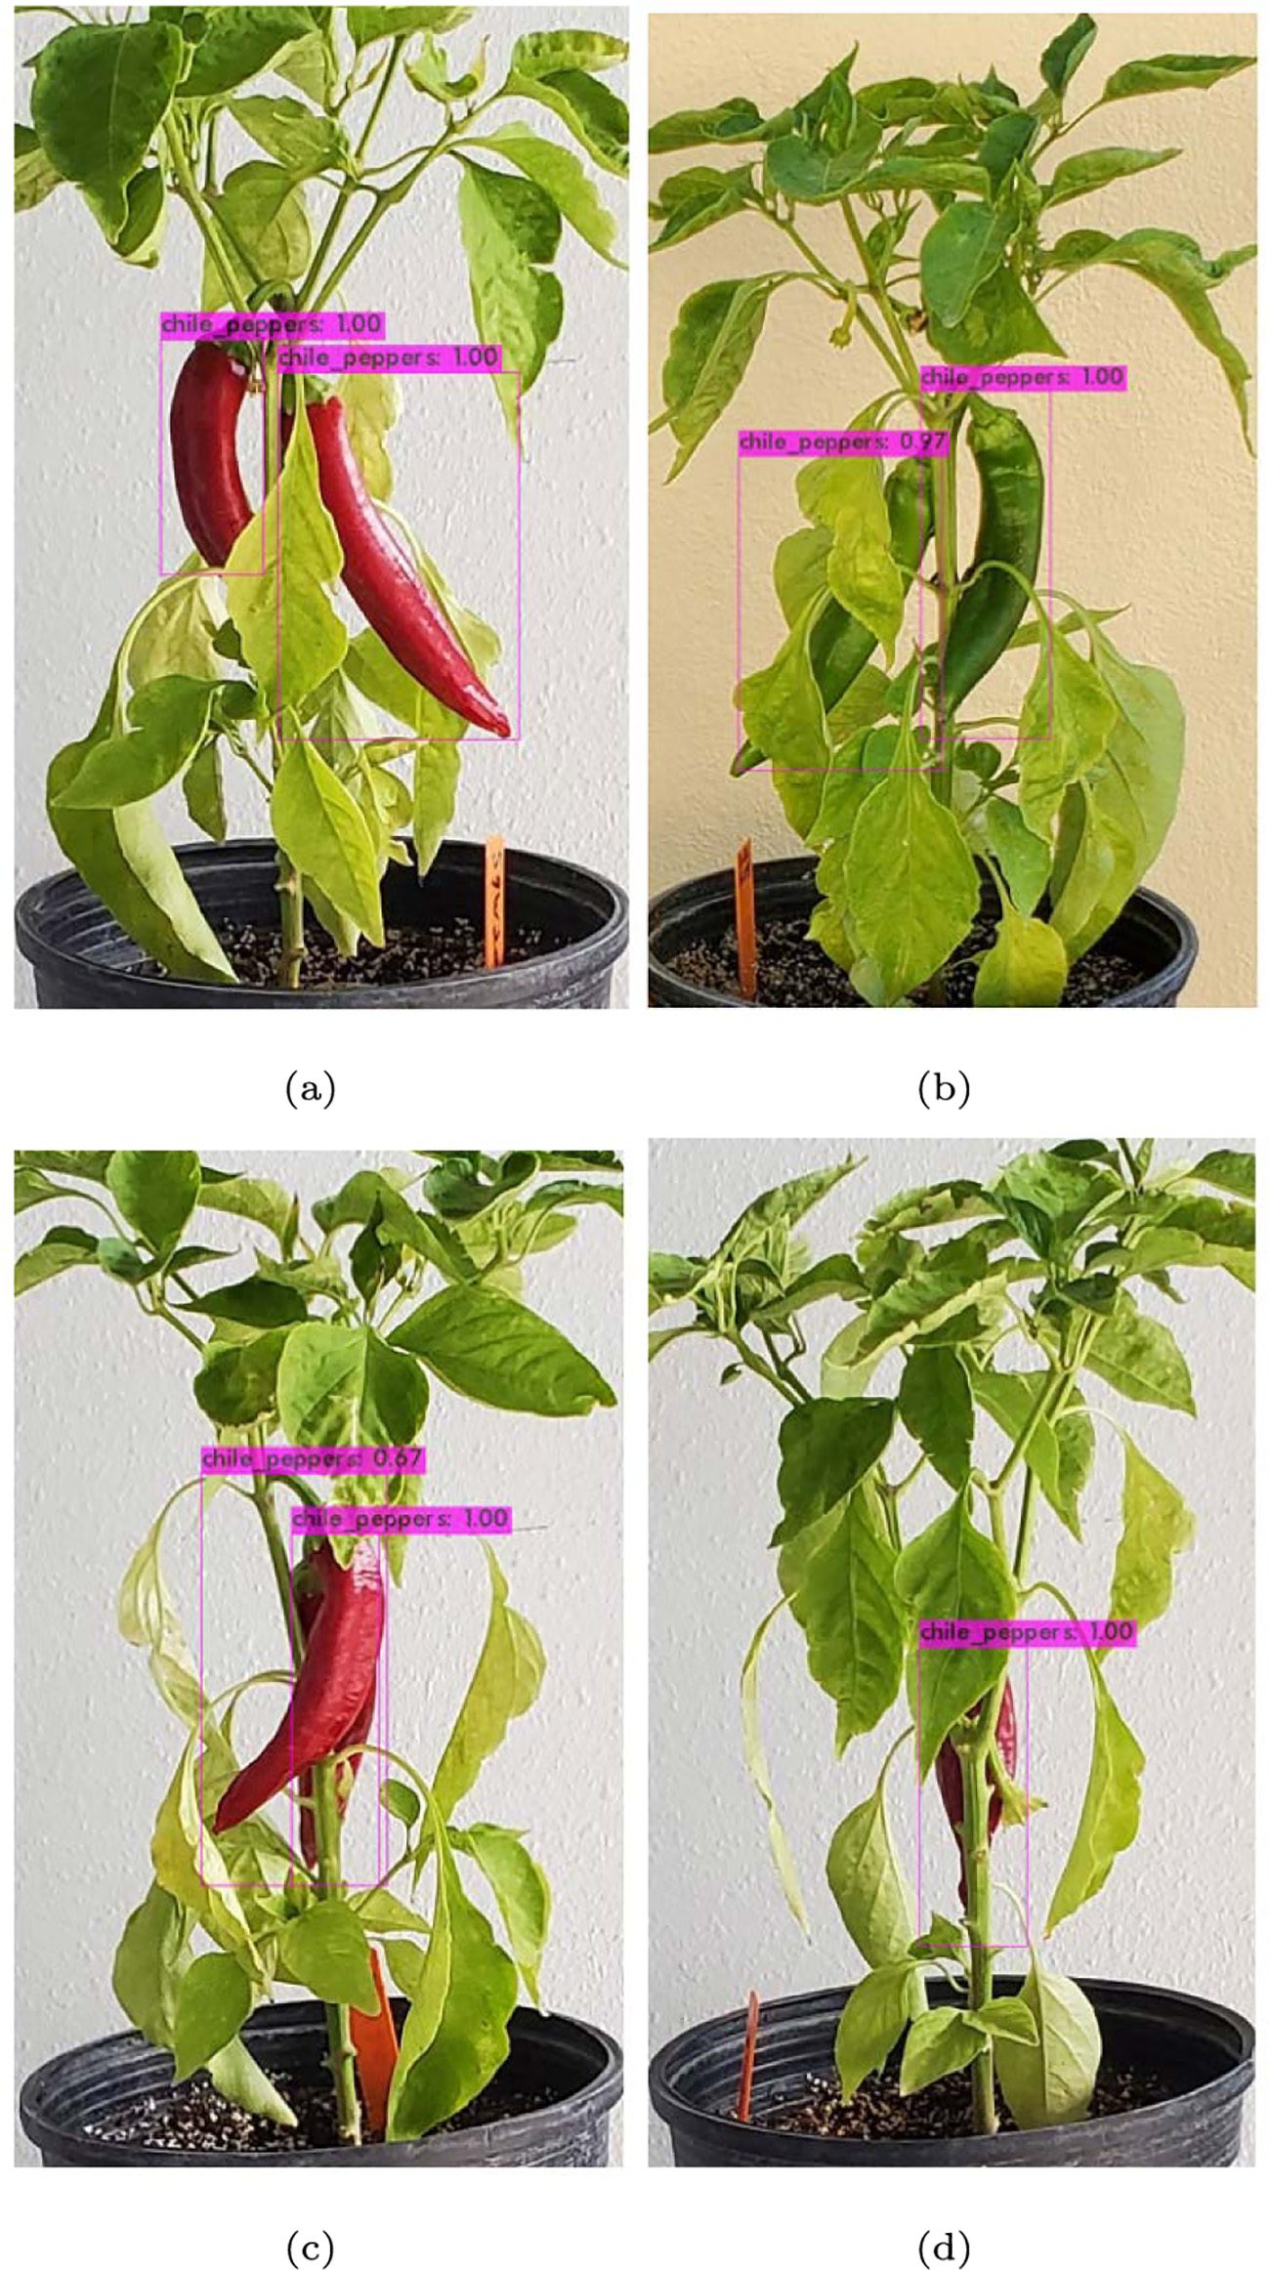

Fig. 18. Additional predictions on validation dataset with YOLOv3: (a) Prediction test image 2, (b) Prediction Test Image 3, (c) Prediction Test Image 4, (d) Prediction test image 5.

113

S.C. Hespeler, H. Nemati and E. Dehghan-Niri Artificial Intelligence in Agriculture 5 (2021) 102–117

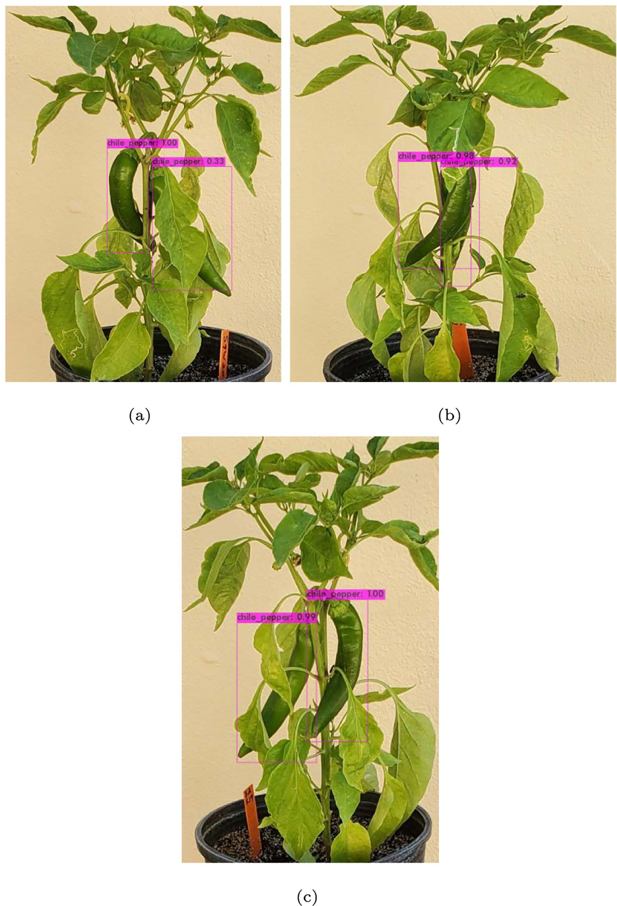

Fig. 19. Predictions on green chili test set via YOLOv3: (a) Prediction test image 2, (b) Prediction test image 3, (c) Prediction test image 4.

Fig. 16 visualizes the truth and prediction bounding boxes for 2 im-

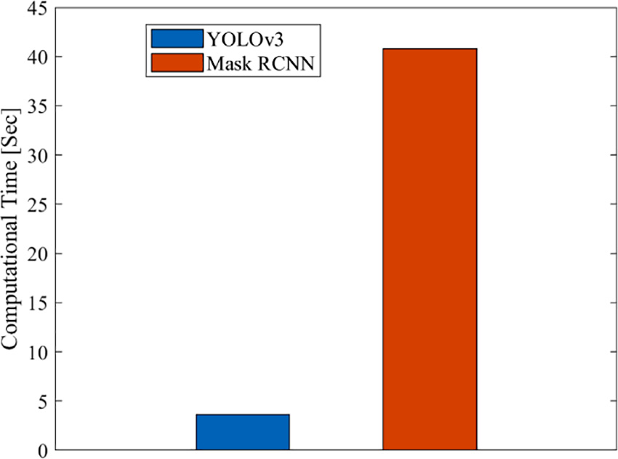

Fig. 20. Computational time (sec) for two-stage and one-stage algorithms.

114

S.C. Hespeler, H. Nemati and E. Dehghan-Niri Artificial Intelligence in Agriculture 5 (2021) 102–117

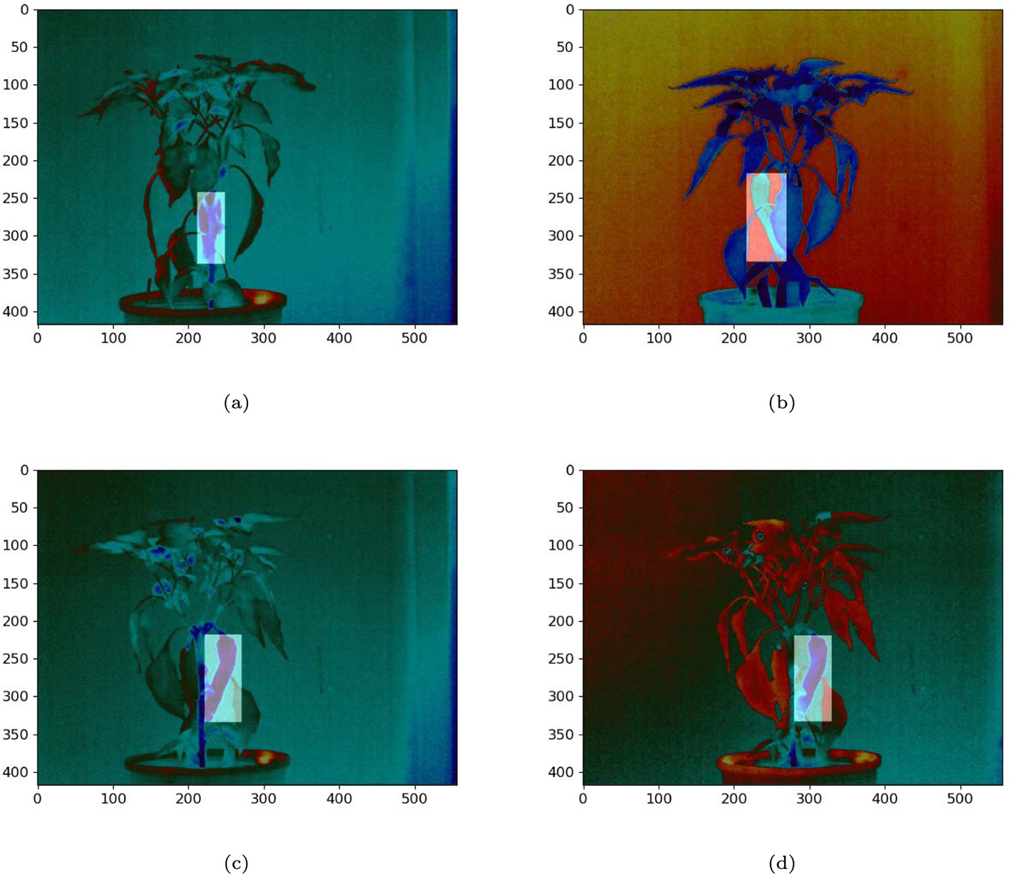

Fig. 21. Thermal images with Masks: (a)Mask 1, (b)Mask 2, (c) Mask 3, (d) Mask 4.

training loss drops below 2.0 roughly at the 250th epoch. After training real-time robotic harvesting where the environment may be dense with

was complete, we evaluated the model using mAP performance metrics. debris.

Both training and testing resulted in 100% precision accuracy (mAP) with a computational time of 3.64 s per test image.

An initial test was conducted using out-of-box pre-trained weights and classes on the chili dataset. Fig. 17 compares the out-of-box likeness scores of a chili pepper to that of a chili pepper image after training was

Fig. 20 compares the computational capabilities of Mask-RCNN (red) to YOLOv3 (blue). The YOLOv3 algorithm has superior capabilities to the Mask-RCNN with over ten times the computational speed on the chili dataset. For this reason, we believe the YOLOv3 algorithm will be suit-able in a harvesting robot for real-time object detection. Computational

complete. speeds for the YOLOv3 and Mask R-CNN are the same on the RGB and

Fig. 18 displays confidence levels of additional test images. As stated earlier in the text, confidence scores mostly evaluate test images be-

thermal images. The following section reports mAP values and com-pares classification performance for the two models with the RGB and

tween 97 and 100% as the predefined class of ‘chile pepper’. thermal datasets.

Confidence scores suggest that the YOLOv3 model is functioning with a high level of precision. There does appear to be an issue of debris in Fig. 19 a). Here, we can see that one of the peppers is only detected with a confidence of 33% which indicates a possible impediment during

In this section, using the RGB dataset, it was shown that accuracy of prediction can significantly decrease when there are heavy debris and overlapping of peppers. In addition, the variant ambient lighting can hamper the performance of detection algorithms based on RGB data.

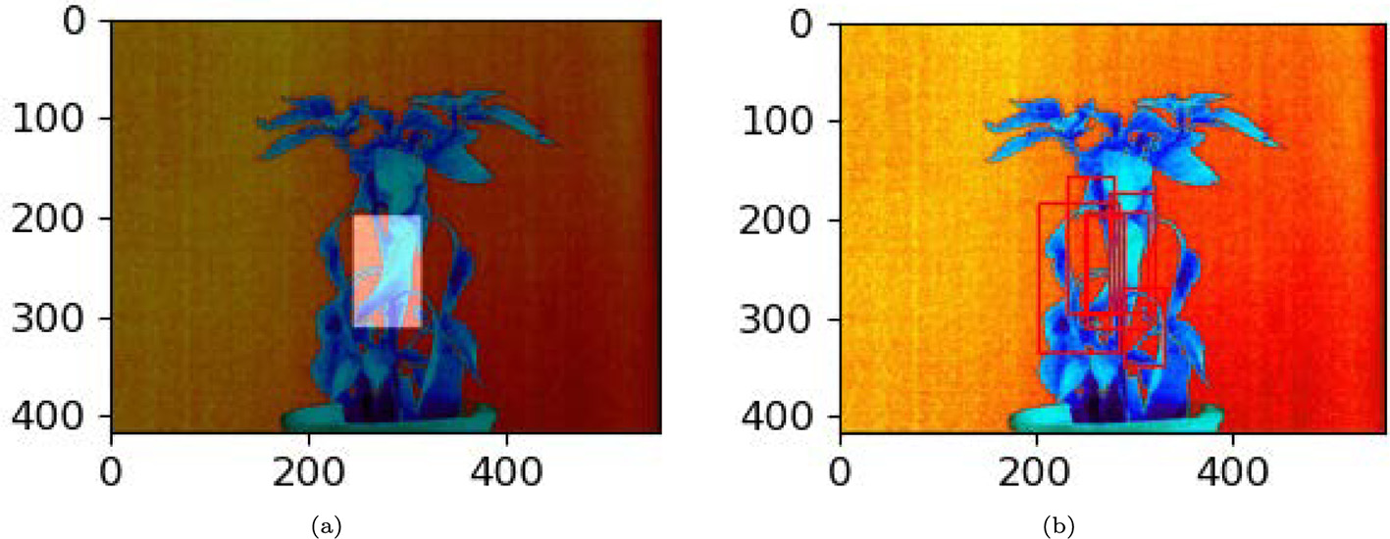

Fig. 22. Comparison of thermal Mask R-CNN: (a) Actual plot, (b) Predicted plot.

115

|  |  |
| --- | --- |
| S.C. Hespeler, H. Nemati and E. Dehghan-Niri  Table 4  YOLOv3 mAP values. | Artificial Intelligence in Agriculture 5 (2021) 102–117  Performance of the Mask R-CNN during this portion of our investiga-tion leads us to doubt the possibility of using the model for real-time ap- |

|  |  |  |  |
| --- | --- | --- | --- |
| RGB |  | Thermal |  |
| Train | Test | Train | Test |
| 1.0 | 1.0 | 0.99 | 0.97 |

plications with thermal imagery. The YOLOv3 model, however showed promising results. Table 4 displays RGB and thermal mAP values for the YOLOv3 architecture. There is a slight decline in performance from RGB to thermal; however compared to the decline that occurred with the Mask R-CNN architecture, this decline is acceptable.

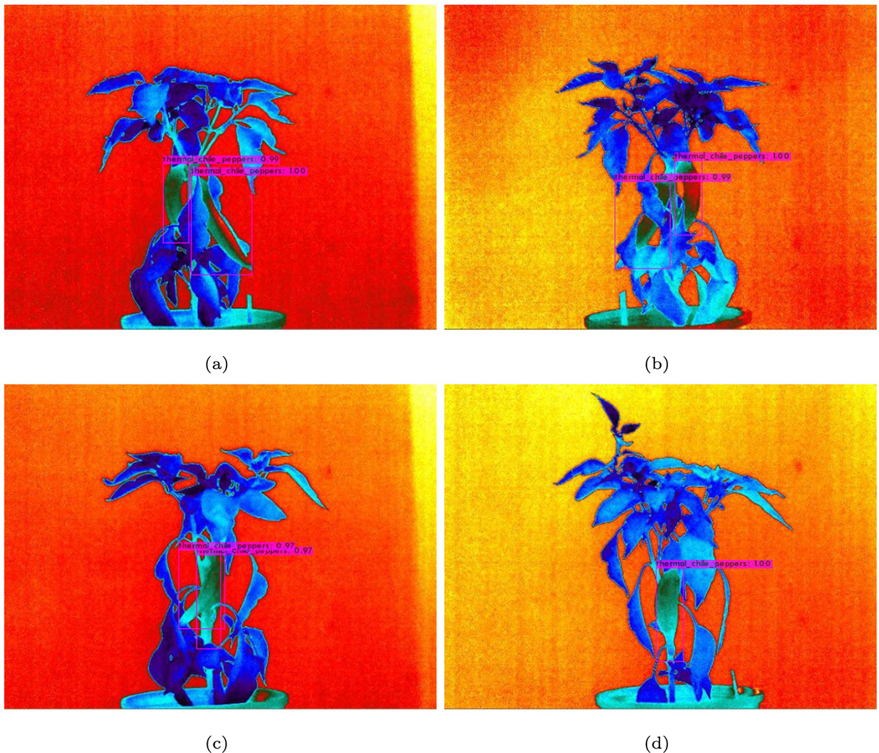

Fig. 23. Thermal chili predictions on validation dataset with YOLOv3: (a) Prediction test image 2, (b) Prediction test image 3, (c) Prediction test image 4, (d) Prediction test image 5.

In the following section, non-destructive thermal imaging will be used to resolve these issues as well as highlight results of the Mask R-CNN and YOLOv3 models used with the thermal dataset.

Fig. 23 demonstrates how thermal imaging can be useful for predic-tions made with debris. When we compare test images 2, 3, and 5 in Figs. 18 and 23 we can see that prediction scores do not significantly change. However, test image 4 shows a dramatic improvement in

|  |  |
| --- | --- |
| 4.4. Thermal imaging | Fig. 23. In Fig. 18 (c) where there is overlapping of peppers, prediction scores for the peppers are reported as 1.00 and 0.67. Compared to the |

The same process conducted with the RGB dataset was used with the thermal dataset. 80% of the images were used for training with 20% held for testing. Predictions from the Mask R-CNN model did not benefit from thermal imaging and Prediction performance was decreased dras-tically. Table 3 displays the comparison of mAP values from the RGB and thermal imagery datasets showing precision reduced over half. We see testing mAP values drop by almost 0.6 for the Mask R-CNN, which is concerning since these models only predict on one class.

same pepper configuration, Fig. 23 (c) shows that both peppers are pre-dicted at scores of 0.97.

Prediction performance of YOLOv3 with the thermal image dataset showcases the possibility of utilizing object detection for robotic har-vesting with debris, paper overlapping, and low light present. Further testing should be conducted to determine the possibility of using object detection for robotic harvesting during evening and night hours.

Fig. 21 shows how the masks were applied during training to a vari- 5. Conclusion

ety of different images. Fig. 21a demonstrates an image in heavy debris

due to the pepper location directly behind the plant stem. Figs. 21b through 21d demonstrate peppers in light debris. We see how debris negatively affects prediction for the Mas R-CNN in Fig. 22. A detailed in-spection of the figure reflects the tabular results by comparing actual and predicted plots of a test image. In Fig. 22a, the image shows one bounding box applied to a single pepper however, the Mask R-CNN model predicted 7 bounding boxes on the test image which decreases the mAP value significantly.

116

S.C. Hespeler, H. Nemati and E. Dehghan-Niri

algorithm has superior capabilities to the Mask-RCNN with over ten times the computational speed on the chili dataset. The YOLOv3 model introduces a spike in model performance for real-time detection (~3 s predictions) and demonstrates the possibility of being utilized during real-time robotic harvesting. However, we reported a lack of confidence in detection when heavy amounts of debris and paper over-lapping are present in RGB images. In this study, it was shown that non-destructive thermal imaging can resolve these issues. In particular, YOLOv3 demonstrated an ability to detect peppers in areas with high debris and pepper overlapping with the thermal imagery; however the Mask R-CNN model did not detect well on the thermal imagery. It was shown that mapping temperature differences between the pepper and plant/debris can provide significant features for object detection in real-time and can help improve accuracy predictions with heavy debris, variant ambient lighting, and overlapping of peppers. In addition, suc-cessful thermal imaging for real-time robotic harvesting could allow the harvesting period to become more efficient and open up harvesting opportunity in the evening hours or low light situations.

Further investigation should be pursued to improve object detection when dense debris and poor ambient light are present. One issue in our experimentation is that only one class was used during training. This issue could lead to overfitting and could be the reason that YOLOv3 per-formed so well on the datasets. Additional classes and variations in im-agery type should be utilized during training and testing to avoid overfitting. We plan to expand the number and type of images in the dataset and determine if the YOLOv3 (or other models) can exceed per-formance expectations during real-time robotic harvesting in dense de-bris and poor lighting environments with peppers in natural environment.

Declaration of Competing Interest

The authors declare that they have no known competing financial interests or personal relationships that could have appeared to influ-ence the work reported in this paper.

References

Abdulla, W., 2017. Mask r-cnn for Object Detection and Instance Segmentation on Keras and Tensorflow. <https://github.com/matterport/MaskRCNN>.

Bochkovskiy, A., 2020. Yolov3 With Darknet Framework. [https://github.com/AlexeyAB/](https://github.com/AlexeyAB/darknet)  [darknet](https://github.com/AlexeyAB/darknet).

Bochkovskiy, A., Wang, C.Y., Liao, H.Y.M., 2020. [Yolov4: optimal speed and accuracy of ob-](http://refhub.elsevier.com/S2589-7217(21)00019-2/rf0015) [ject detection. arXiv 2004.10934 (preprint arXiv:2004.10934)](http://refhub.elsevier.com/S2589-7217(21)00019-2/rf0015).

Bosland, P.W., Bailey, A.L., Cotter, D.J., 1991. [Growing Chiles in New Mexico. Guide H-New](http://refhub.elsevier.com/S2589-7217(21)00019-2/rf0020)  [Mexico State University, Cooperative Extension Service (USA)](http://refhub.elsevier.com/S2589-7217(21)00019-2/rf0020).

Common Objects in Context (COCO), 2015. Detection Evaluate. [https://cocodataset.org/](https://cocodataset.org/detection-eval)  [detection-eval](https://cocodataset.org/detection-eval). Online; accessed 19 January 2021.

Dalal, N., Triggs, B., 2005. Histograms of oriented gradients for human detection. 2005 IEEE computer society conference on computer vision and pattern recognition (CVPR’05). 886–893. IEEE. <https://doi.org/10.1109/CVPR.2005.177>.

Deng, J., Dong, W., Socher, R., Li, L.J., Li, K., Fei-Fei, L., 2009. [ImageNet: a large-scale hierar-](http://refhub.elsevier.com/S2589-7217(21)00019-2/rf0030) [chical image database. CVPR09, pp. 248–255](http://refhub.elsevier.com/S2589-7217(21)00019-2/rf0030).

Everingham, M., Van Gool, L., Williams, C.K.I., Winn, J., Zisserman, A., 2007. The PASCAL Visual Object Classes Challenge 2007 (VOC2007) Results. [http://www.pascal-net-work.org/challenges/VOC/voc2007/workshop/index.html](http://www.pascal-network.org/challenges/VOC/voc2007/workshop/index.html).

FAO, 2019. Food and Agriculture Organization of the United Nations Statistics Division.

(ACCESSED 23 FEBRUARY 2021). <http://www.fao.org/faostat/en/data/QC/visualize/>. Felzenszwalb, P., McAllester, D., Ramanan, D., 2008. A discriminatively trained, multiscale, deformable part model. 2008 IEEE Conference on Computer Vision and Pattern Rec- ognition. 1–8. IEEE. <https://doi.org/10.1109/CVPR.2008.4587597>.

Gao, Z., Shao, Y., Xuan, G., Wang, Y., Liu, Y., Han, X., 2020. Real-time hyperspectral imaging for the in-field estimation of strawberry ripeness with deep learning. Artif. Intell. Agric. <https://doi.org/10.1016/j.aiia.2020.04.003>.

Girshick, R., 2015. Fast r-cnn. Proceedings of the IEEE International Conference on Com- puter Vision, pp. 1440–1448. <https://doi.org/10.1109/ICCV.2015.169>.

Girshick,R.,Donahue,J.,Darrell,T.,Malik,J.,2014.Richfeaturehierarchiesforaccurateobject detectionandsemanticsegmentation.ProceedingsoftheIEEEConferenceonComputer Vision and Pattern Recognition, pp. 580–587. <https://doi.org/10.1109/CVPR.2014.81>. Gu, J., Wang, Z., Kuen, J., Ma, L., Shahroudy, A., Shuai, B., Liu, T., Wang, X., Wang, G., Cai, J., et al., 2018. Recent advances in convolutional neural networks. Pattern Recogn. 77, 354–377. <https://doi.org/10.1016/j.patcog.2017.10.013>.

117